**University of Petroleum and Energy Studies**

School of Computer Science

Department of Cybernetics



**Graphics and Animation Tools**

**(Lab File)**

Course: B.Tech Branch: CSE (OSOS)

Batch: 2017-2021 Semester: 7th

**Submitted By:**

**Akshit Chauhan**

**Roll No.: R100217004**

**Sap ID: 500062444**

**(Batch 1)**

**VIVA-2**

Aim- Create any Mountain Range with Snowfall over it using GIMP

1. Open GIMP, create a new layer with white background.

2. Open an image of the mountain as layers in GIMP and create a new

transparent layer to draw boundaries.

3. Use the ‘Paths tool’ over the image and start selecting boundaries and layout of the image.

4. After selection of layout/ boundaries, go to ‘Select’, choose the ‘From Path’

option and your path will be selected.

5. After the path is selected click on ‘bucket fill tool’ from the toolbar and

colour the mountain with your desired colour.

6. Repeat step 3,4,5 for creating the grass and sky of the scene.

7. Structure of the mountain scene is complete.

8. Use your creativity to style the snow cap and when you feel it’s good, then

place it at the top of the mountain range.

9. For adding snowfall effect, add a new layer of black colour over all the

layers and set the photo effect from normal to screen.

10. Go to Filters -> Noise -> RGB Noise and then press ‘OK’, this will add

some noise to the image and make it translucent.

11.Again, Go to Filters -> Blur -> Pixelated and then press ‘OK’, this will make

the noise effect pixelated.

12.Then, Go to Filters -> Blur -> Motion Blur and then press ‘OK’.

13.After completing the above steps, Go to Colors -> Levels and adjust the

white and black input levels till you find a pixelated snow effect over your image.

14.Remove the extra layer

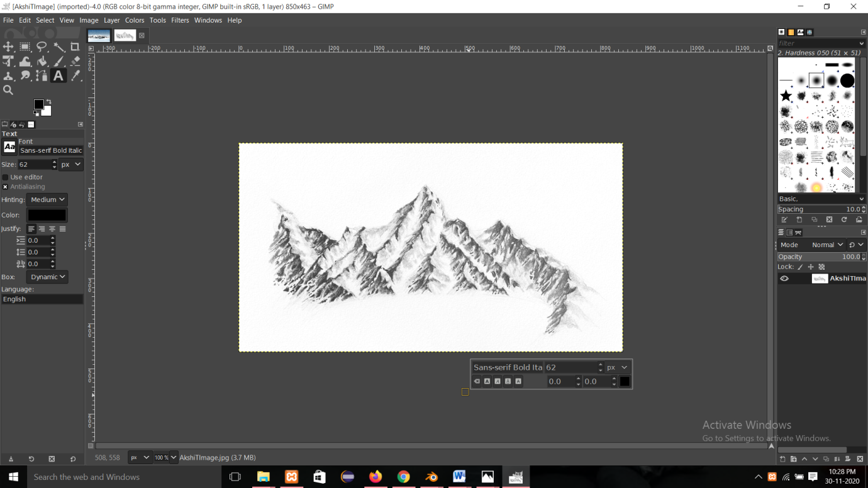

Aim- Create any City or Skyscraper using Blender

Step-1

we start off with a cube but first off we need to measure the height of an average floor of a skyscraper which is about 3 meters on average so we use the measure tool and measure around 3 meters then we position the cube and a scale it so that it fits the height of 3 meters then we add a loop cut to start defining the frames of the window so WE just add one loop cut by hitting ctrl R right down the middle and then just move it all the way to the edge now they need to do one side only the horizontal side and the vertical side this will represent our window frame

Step-2

I'll just turn on cavity and turn up the ridges and valleys so that we can see everything a little bit better so now I'll go ahead and add an array modifier and as you can see the window frame now looks more complete we also duplicated an extra window frame to the side because we want to use that later on so turning up the array modifier we turn the count to about 8 since we want my floor to be around 16 windows long so the reason why we chose 8 is because later on I'm going to go ahead and use the mirror modifier so now we go ahead and set up the materials

Step-3

Now, this is where the extra skyscraper comes in handy so we'll go ahead and apply the same materials to this one as we’ll should have done that earlier and then we also forgot to add the materials to the back of the windows as we’ll so I'll just do the same thing the reason why is because we want the window to be see through the window we'll have a bit of thickness to the glass so now we rotates the extra pane exactly 45 degrees and then position it to fit the corner of the skyscraper

Step -4

Now, try to lean the clear coat up or try doing some roughness up as we’ll you can play around with the colours eventually we didn't quite like to look we was getting from the principal shade and we changed to a plain old glossy shade mixed with a glass shade we think we like the look of that instead with this Shadrach and sort of seal inside the building but we wanted to be mostly reflective rather than see-through so this point we start to adjust a different camera angle we added a vector mapping node and a texture coordinate to rotate the world a bit move the Sun so that we can see the sunlight and the reflection of the sunlight in the skyscraper eventually we got the look.

Step-5

We finally managed to create a final render of the skyscraper and added some compositing effects like lens distortion and colour grading to create a beautiful output image.

